**Geospatial Mapping of Traffic Signal Sensors Used for Traffic Management in Mississippi**

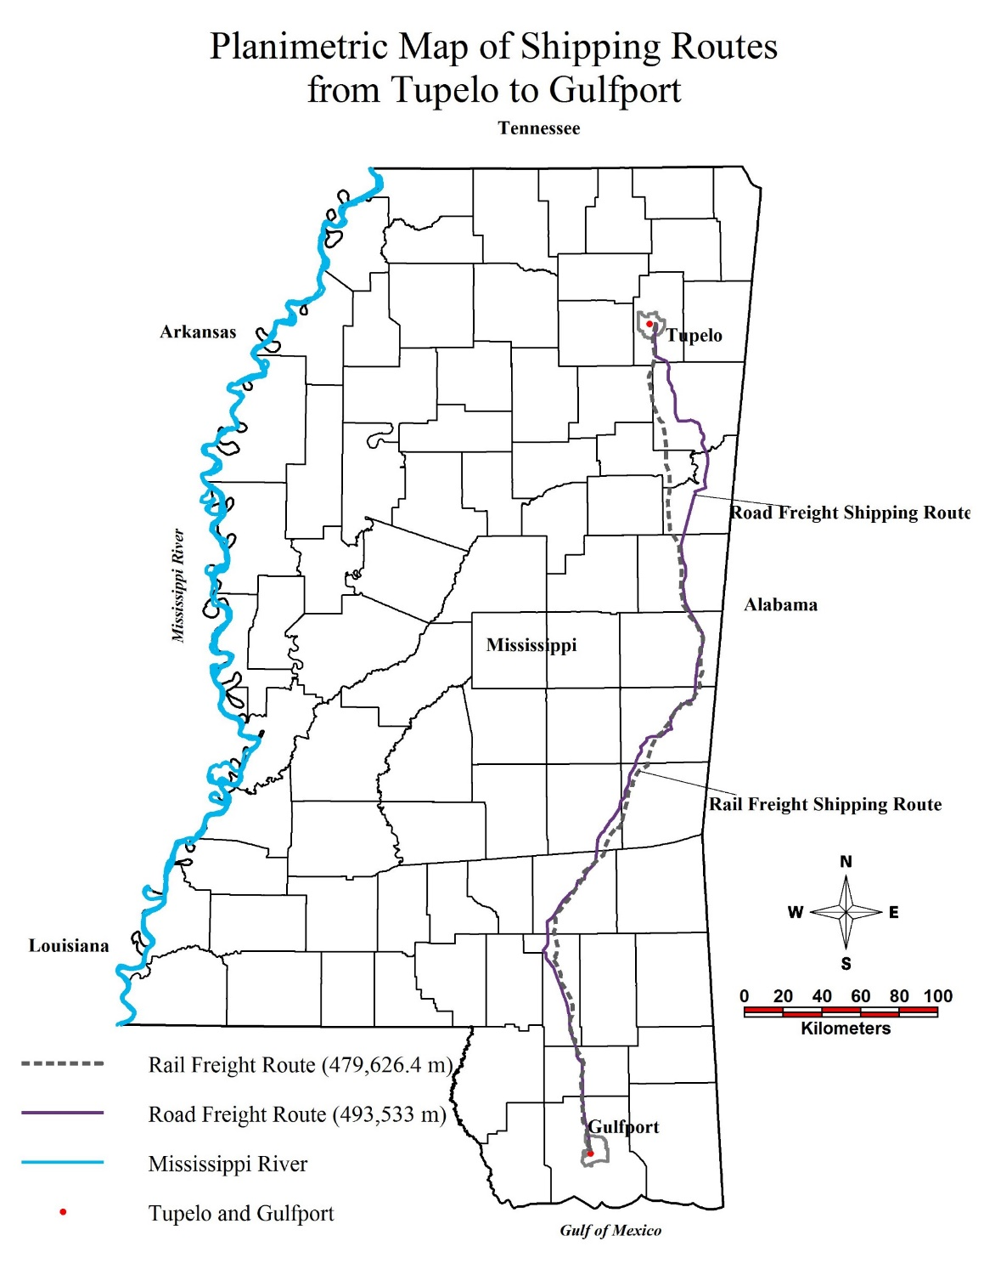

CE 581 Multimodal Transportation Engineering

Instructor: Dr. Waheed Uddin

Fall 2017

Term Project

Author: William Rossell

Submitted: December 1, 2017

**Table of Contents**

**Executive Summary Page 3**

**IntroductionPage 4**

**BackgroundPage 4**

**ObjectivesPage 4**

**Approach and MethodologyPage 5**

**Data and Spatial InformationPage 6**

**Step By Step Data Processing and AnalysisPage 7**

**Creating a Connection to a DatabasePage 7**

**Create A LegendPage 8**

**Creating Buffer Zone Vector MapsPage 8**

**Create A FeaturePage 16**

**Performing PlanimetricsPage 19**

**Creating a Map LayoutPage 21**

**Interpretation and Discussion of ResultsPage 24**

**Conclusions and Benefits of Study Thus FarPage 32**

**AppendicesPage 33**

**Executive Summary**

A common source of air pollutants is the emissions from an automobiles exhaust system. From the moment the combustion engine is started, emissions are introduced into the surrounding environment. However, emissions are not only based on the conditions of the engine itself, but the situation of the load for a vehicle or locomotive may be transporting. This report aims to observe and analyze the efficacy and cost efficiency of different modes of freight shipment in the agricultural field (i.e. cotton).

Resources used throughout this report were gathered from the US Census Bureau and the Mississippi Department of Transportation, as well as other sites and organizations listed in references. Calculations and analysis was performed using criteria and guidelines provided from Dr. Waheed Uddin. Due to time constraints and restricted sources of information, the data presented throughout this report will not be fully accurate. However, this report will serve as an example for future endeavors in any project which puts forward the effort to advance the free market that is agriculture while maintaining the integrity of businesses and environmental stability and sustainability.

In this report, spatial maps and planimetric mapping and analysis will be presented for the purpose of display data such as distance to be traverse by freight transporting methods. There will also be a cost analysis presented for possible alterations of shipping methods based on an assumed annual growth factor of 2% to be applied to the amount of a commodity to be shipped.

**Introduction**

**Background**

In recent years, the study on whether or not the level of pollutants in the atmosphere has risen has been ongoing. What cannot be argued, however, is that certain substances in the air have been harmful to the environment. This has been studied from many perspectives, and the emissions due to transport of freight has been a regular study by different shipping establishments in an effort to conform with the regulations and restriction of the Environmental Protection Agency.

Automobiles of all shapes and sizes, from passenger cars to large railcars, cause emissions due to the burning of fuel. Whenever the engine is active, fuel is being consumed, often by a combustion engine. This combustion happens regardless of whether the machine is loaded, however when in motion, the amount of emissions can be correlated to the amount different engines, each with a different level of efficiency, may be moving. Therefore, when freighters are in motion while fully loaded, more fuel is being combusted and more emissions are being released.

For this reason, this study seeks to find a balance between cost efficiency of shipping and environmental health and sustainability of alternate shipping methods.

**Objectives**

The primary objective of this study has been to observe whether or not the current methods of freight transportation are optimal and sustainable from an environmental point of view.

The secondary objective to decide whether any improvements in delivery speed and rate of emission by use of multi-modal transport, rather than a dependence on rail, are fiscally feasible.

Tertiary objectives have been to analyze emissions currently produced by rail freight transportation of cotton and to compare these emissions to those produce by truck freight transportation of cotton.

Other tertiary objectives were to analyze freight travel demand after 10 years assuming a 2% growth rate and to observe value engineering methods of benefit-cost analysis for any proposed improvements to transportation methods.

**Approach and Methodology**

For the primary objective, this report made use of Google Earth, GeoMedia Pro to create and analyze spatial maps representing data distance of freight transport to create a reference datum (from the cities of Tupelo, MS, to Gulfport, MS) for which quantitative analysis could be performed.

For the secondary objective, several quantitative analyses were performed in order to gauge the performance of different variation in the pattern of freight shipment when referring to cost efficiency and environmental sustainability.

For the tertiary objectives, the following sets of equations and processes were used as tertiary objectives often serve the purpose of completing and accommodating higher order objectives.

${Emissions}_{Truck}=Emission Factor*Distance Shipped$**Eqn. 1**

${Emissions}_{Rail}=Emission Factor*(Distance Shipped*Weight Shipped)$**Eqn. 2**

$Adjusted Demand=Current Freight Produced*\left(\frac{{(1+i)}^{n}-1}{i{(1+i)}^{n}}\right)$**Eqn. 3**

Where, “i” denotes the annual growth factor equivalent in this study to 2%.

“n” denotes the years of factored growth desired.

$Total Product Value=Adjusted Values-Adjusted Cost$**Eqn. 4**

Where all values and costs are adjusted in the same manner as demand in **Eqn. 3**.

**Data and Spatial Information**

The purpose of this study was to analyze the cost efficiency and environmental sustainability of changing the distribution of freight across different shipping methods in the state of Mississippi.

All information on emission factors were gather from Dr. Waheed Uddin as well as information from the Environmental Protection Agency. Databases used for the creation of maps were provided by the Center for Advanced Infrastructure Technology. Images for the planimetric analyses were compiled from Google Earth. All maps were made using GeoMedia Pro Classic 2013.

**Step By Step Data Processing and Analysis**

**Creating a Connection to a Database**

Step 1: Open a blank GeoWorkSpace in GeoMedia Pro Classic 2013.

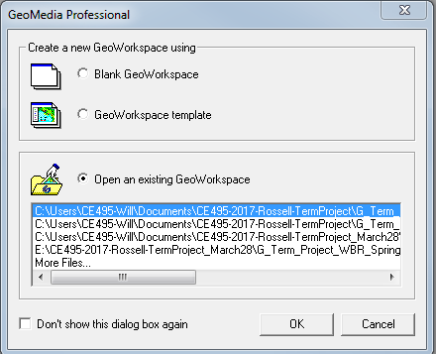

**Figure 1: *Creating a New GeoWorkSpace***

Step 2: Locate the Warehouse tab, accessing the drop down menu by clicking this tab.

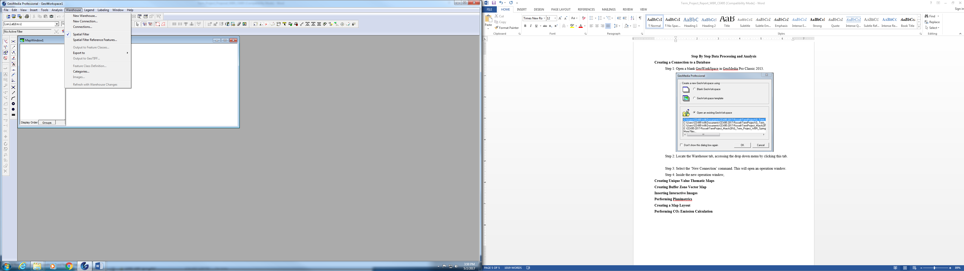

**Figure 2: *Creating a connection with a database***

Step 3: Select the ‘New Connection’ command. This will open an operation window.

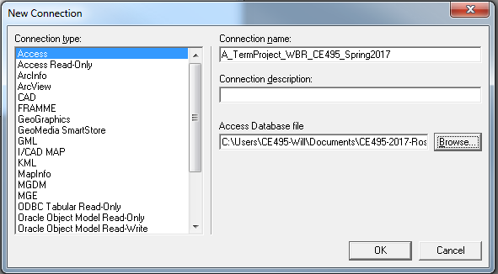

**Figure 3: *Defining Properties of Connections***

Step 4: Inside the new operation window, define the connection type, name the new connection that will be created, one may provide a connection description if it serves a purpose (***this is not necessary***), and finally browse and locate the database sought to be worked in. Finally, click “OK” and this will create a new connection to the database.

**Creating A Legend**

Step 1: Create a legend by locating the Legend tab, selecting and accessing the dropdown menu. Select ‘Add Legend Entries…” command, and in the operation window that appears, select the features that need to be displayed in the Legend. When all features desired are selected, click ‘OK’. Once the Legend has been created, features can be displayed on/off by right-clicking the feature name on the legend.

**Creating Buffer Zone Vector Map**

Step 1: Open a new map window and create a legend as described in the previous section, “Creating A Legend.”

Step 2: Locate the Analysis type, accessing the dropdown menu again, and select the ‘Spatial Intersection…’ command. This will open another operation window.

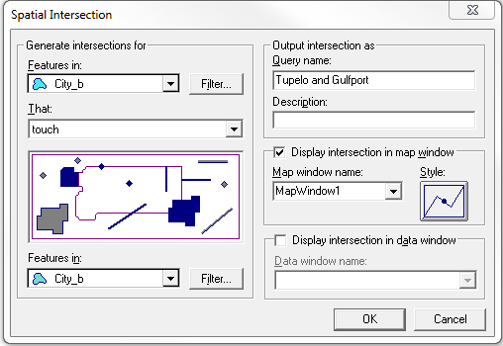

**Figure 4: *Making Spatial Intersection for the isolation of cities: Tupelo and Gulfport, based on MS.mdb provided by CAIT***

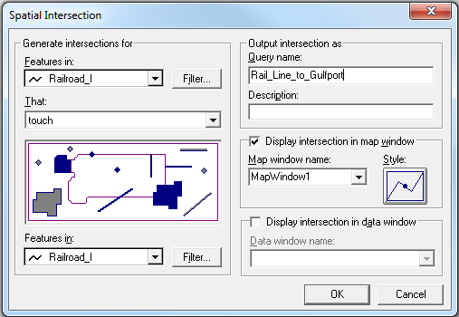

**Figure 5: *Making Spatial Intersection for the isolation of railways between the cities: Tupelo and Gulfport, based on MS.mdb provided by CAIT***

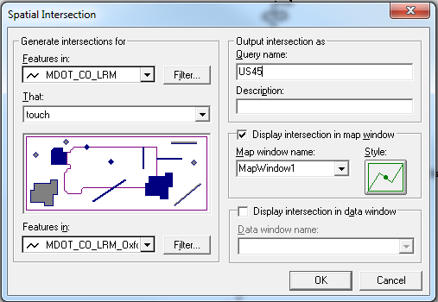

**Figure 6: *Making Spatial Intersection for the isolation of US45 between the cities: Tupelo and Gulfport, based on MS.mdb provided by CAIT***

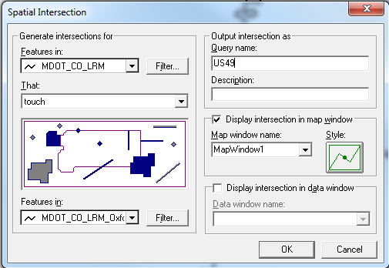

**Figure 7: *Making Spatial Intersection for the isolation of US49 between the cities: Tupelo and Gulfport, based on MS.mdb provided by CAIT***

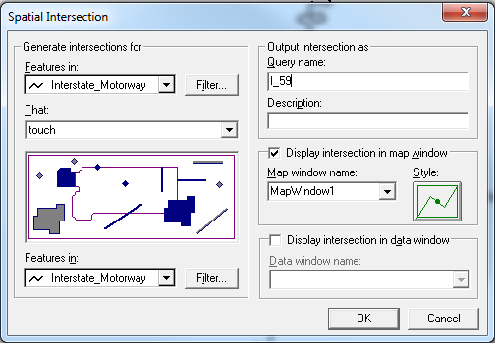

**Figure 8: *Making Spatial Intersection for the isolation of I-59 between the cities: Tupelo and Gulfport, based on MS.mdb provided by CAIT***

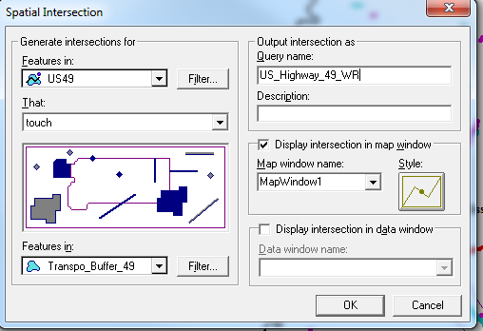

**Figure 9: *Using Spatial Intersection to isolate direct roadways from excess features presented in the GeoWorkspace***

Step 3: Inside the ‘Generate intersections for’ dialogue box, define what to feature classes are to be observed. Further filter the intersection by clicking the ‘Filter…’ command key to the right of the dropdown menu. Also, define the criteria of the search by using the ‘That:’ dropdown menu. When all elements are defined, click ‘OK’. This will display a new query which will encompass all buffered criteria.

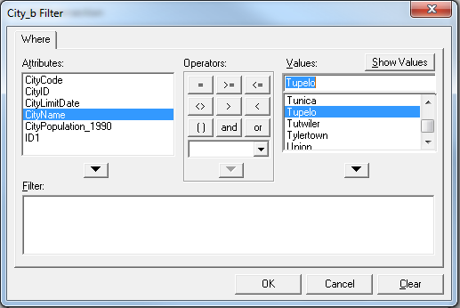

**Figure 10: *Filtering by CityName attribute during creation of Spatial Intersection***

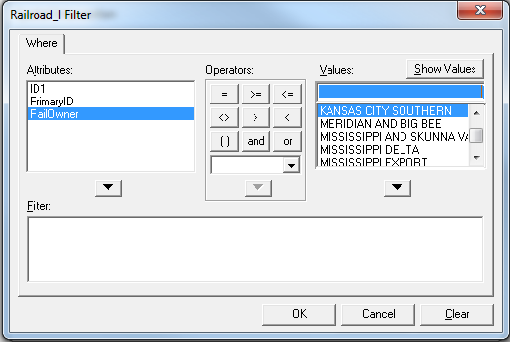

**Figure 11: *Filtering by RailOwner attribute during creation of Spatial Intersection***

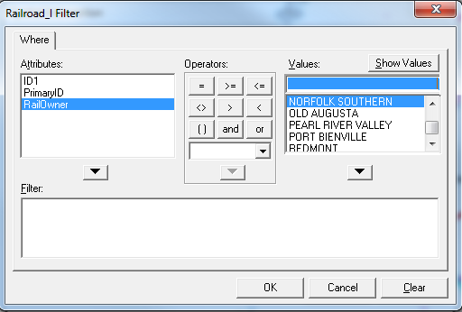

**Figure 12: *Filtering by RailOwner attribute during creation of Spatial Intersection***

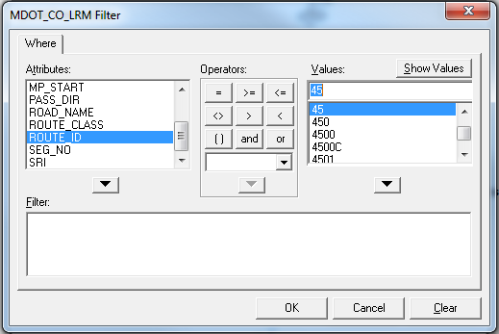

**Figure 13: *Filtering by ROUTE_ID attribute during creation of Spatial Intersection***

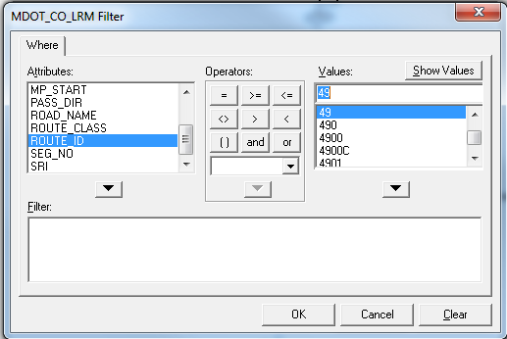

**Figure 14: *Filtering by ROUTE_ID attribute during creation of Spatial Intersection***

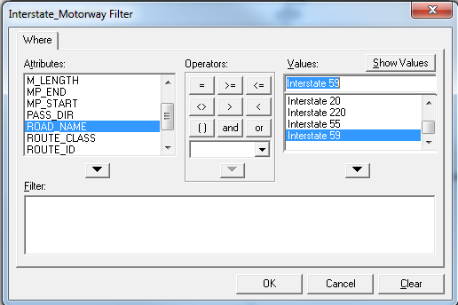

**Figure 15: *Filtering by ROAD_NAME attribute during creation of Spatial Intersection***

Step 4: Return to the ‘Warehouse’ tab, and select the ‘Output to Feature Classes…’ command. Select the spatial intersection that was just created from the queries menu. Once finished, click ‘OK’. This creates a feature class that is capable of being used from any server.

Step 5: Repeat steps 2-5 for every component required in the map desired. Once finished, the final product should be the only item displayed in the legend.

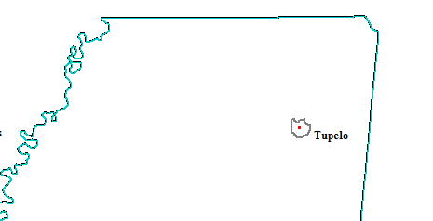

**Figure 16: *Isolated Tupelo FeatureNOTE: Features reflect the CAIT Specifications with the addition of City Border as defined by William Rossell.***

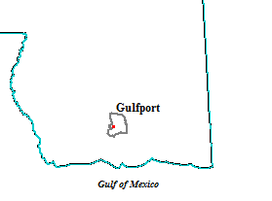

**Figure 17: *Isolated Gulfport Feature NOTE: Features reflect the CAIT Specifications with the addition of City Border as defined by William Rossell.***

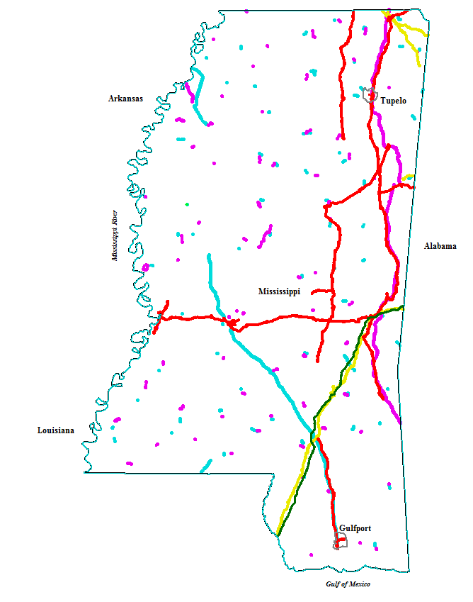

**Figure 18: *Geoworkspace after creation of initial Spatial Intersections. NOTE: Features do not yet reflect CAIT Specifications***

**Creating a Feature**

Step 1: Open the map window that the image will be inserted into. Go to the ‘Warehouse’ tab, locate the ‘Feature Class Definitions…’ command key, and create a new feature class with a geometry type of ‘point’.

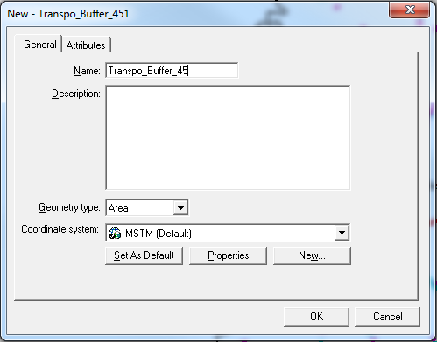

**Figure 19: *Creating a new feature class for buffering roadways***

Step 3: Select the ‘Insert’ tab, access the dropdown menu and select the ‘Feature…’ command.

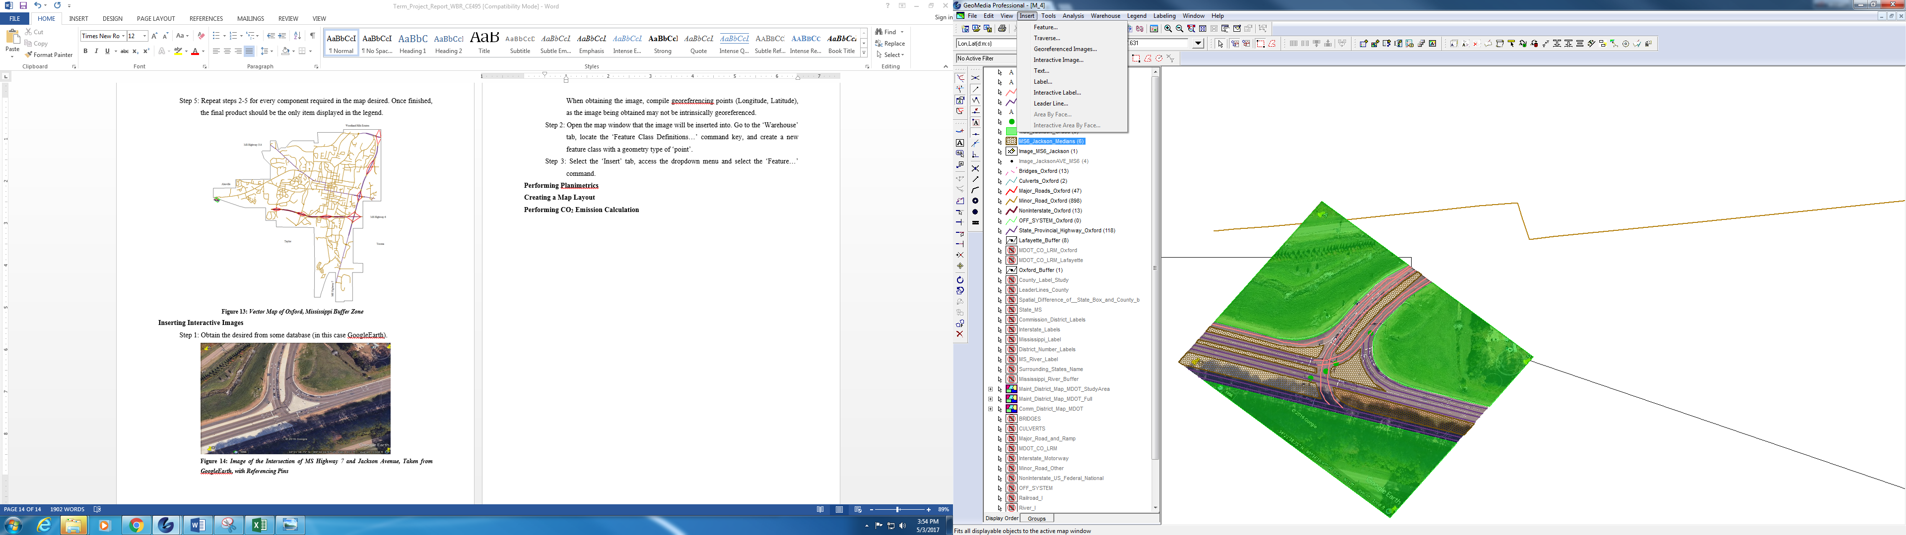 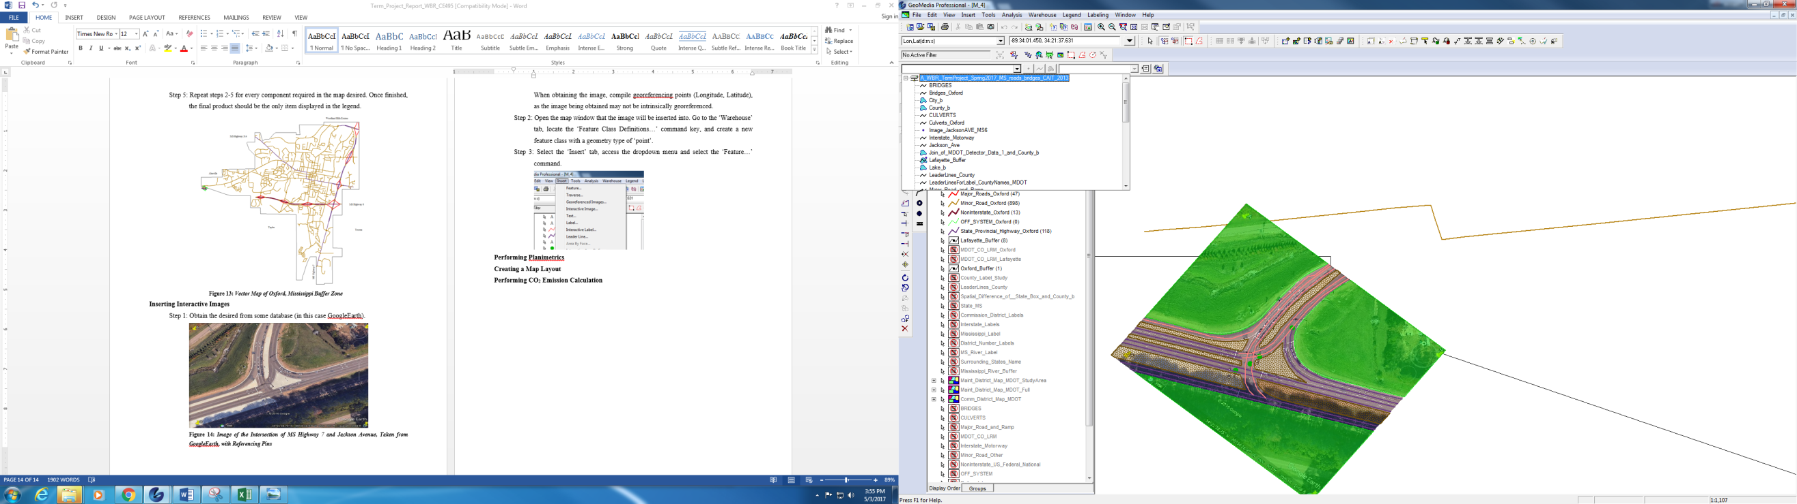

**Figure 20: *Inserting Feature*  Figure 21: *Selecting Feature Class***

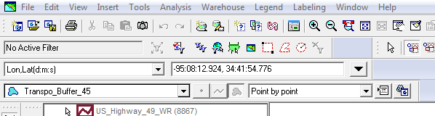

**Figure 22: *Creating a buffer to isolate US45***

This will allow new dialogue boxes to appear, select the feature class created for this purpose of this insertion. Create either points, lines, or areas by clicking point-to-point as desired. When this is finished, press ‘Esc’ key.

Step 4: Repeat step 2 with the change of geometry type that may be necessary. 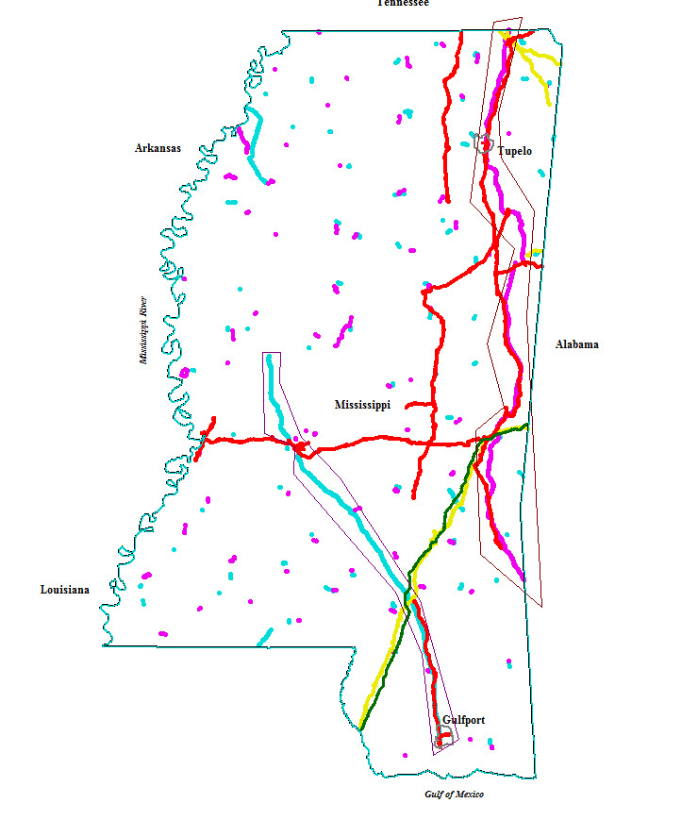

**Figure 23: *Buffering Roadways US45 and US 49 NOTE: Features do not yet reflect CAIT Specifications***

**Performing Planimetrics**

Step 1: Create as many feature classes as necessary using the same steps from procedures mentioned earlier in this report. Make sure geometry types match what is needed. In this instance, two feature classes had to be made of type, “line.”

Step 2: Once the feature classes are created, begin inserting the new features into the aforementioned feature classes by use of the same processes mentioned earlier. These will be point by point insertions, based on the desired information to be gained. Once the process is completed, press the ‘Esc’ key. The new features will now appear in the feature class.

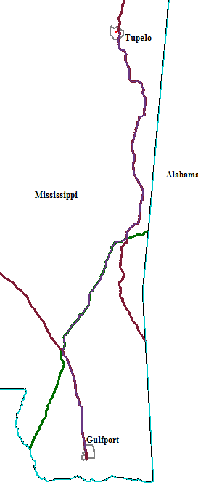

**Figure 24: *Creating Planimetric Overlay of Roadways to Measure Trip Distance from Tupelo to Gulfport***

Step 3: Double click the legend icon next to the feature class name desired. Doing this will allow the style of the feature to be changed, such as used in this study to reflect the specification sent forward by the Center for Advanced Infrastructure Technology.

Step 4: Take note of the physical properties that are access by selecting a feature from the map window and seeing the ‘General’ tab.

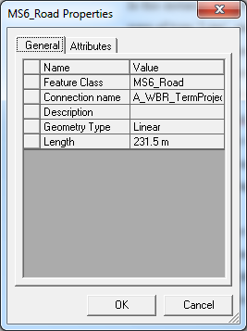

**Figure 25: *General Properties of Planimetric Features***

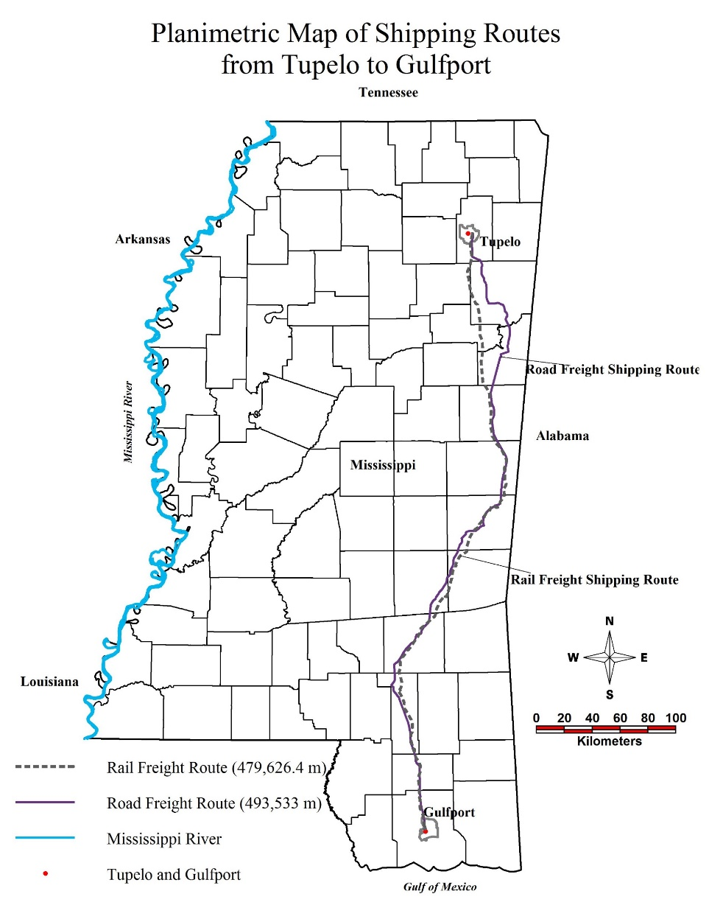

**Figure 26: *Full Planimetrics Mapping of Alternate Routes Between Tupelo, MS, and Gulfport, MS.***

Step 5: Return to the ‘Feature Class Definitions…’ operation window from earlier. Select a feature class that has just been created, then click ‘Edit…’. This allows for the addition of new attributes into the features. Create attributes that reflect the properties observed in step 4 so that the input can easily be used later.

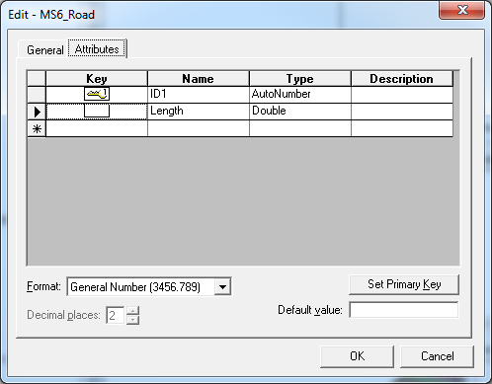

**Figure 27: *Addition of New Attributes into a Feature Class***

**Creating a Map Layout**

Step 1: Locate the Window tab, accessing the dropdown menu, and select the Layout Window. At the bottom of the window, right click on the sheet label tab. This allows for access to page setup.

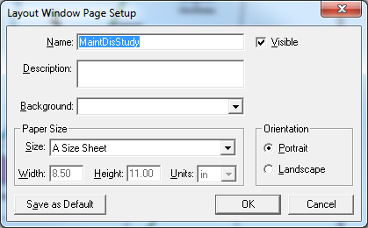

**Figure 28: *Page Setup Command for Sheet Orientation and Naming in Layout Window***

Step 2: Locate the Insert tab, notice that the dropdown menu has changed.

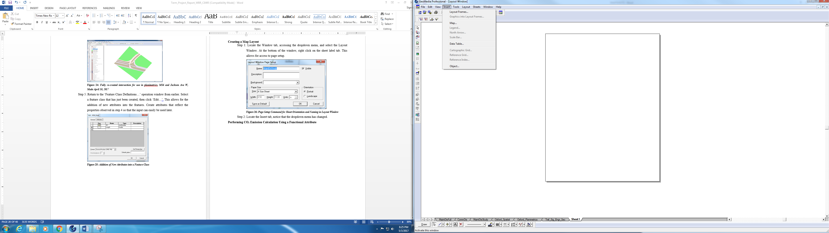

**Figure 29: *Insert Tab Dropdown Menu***

Select the map command key. This allows for a map window of the users choosing to be selected and inserted into the sheet. The map window can be resized for best fit scenario on the layout sheet.

Step 3: Once the map window has been inserted, select it, then double click on it. This will access the Map Properties operation window. Select the General tab, and the make sure the selection box beside ‘Display boundary’ is unmarked. When finished, click ‘OK’.

Step 4: Return to the Insert tab, with the map window still selected, insert a north arrow and scale bar. Double clicking each of these items with allow for their properties to be altered to user’s preference.

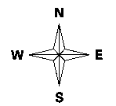 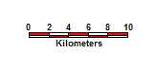

**Figure 30: *GeoMedia North Arrow* Figure 31:*GeoMedia Scale Bar***

Step 5: Return to the Insert tab, with the map window still selected, now inserting a legend. A new operation window will open. This window will allow the user to see all displayed content in the map window.

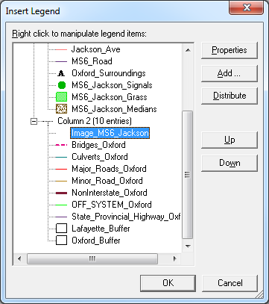

**Figure 32: *Inserting a Legend into the Layout Window***

Right clicking on legend items will allow for removal, addition, and property alterations. By clicking the ‘Properties’ command key, the font style and size of the legend title and legend entries can be changed.Once acceptable, click ‘OK’.

Step 6: Finally, locate the ‘Text’ command key toward the bottom of the screen. This will allow the user to create a textbox, and therefore name the layout with a proper title. Once the title is in place, locate the Sheets tab, access the dropdown menu, and select the ‘Export Layout…’ command. This allows the file to be saved as a “.jpeg” image for future presentation.

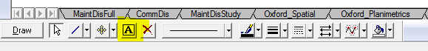

**Figure 33: *Text Command Key for Creating Textboxes***

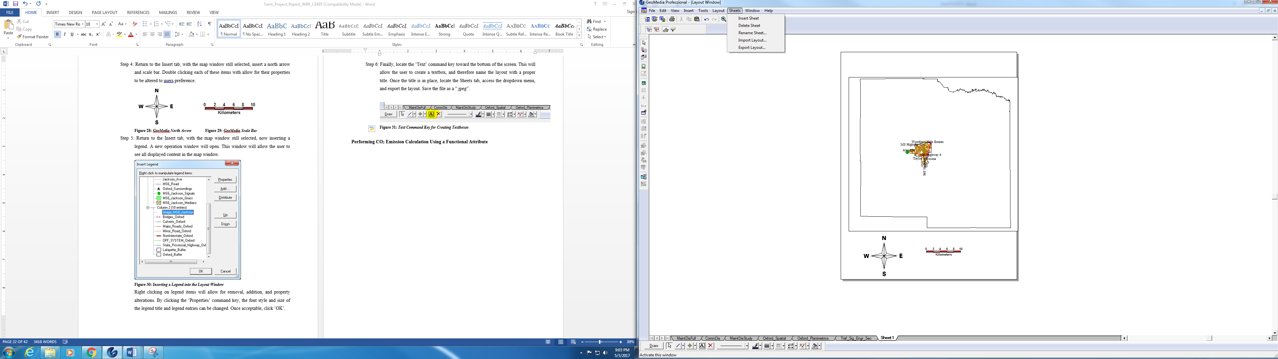

**Figure 34: *Export Layout Command Key for JPEG creation***

**Interpretation and Discussion of Results**

The goal of this study has been to measure and compare the cost efficiency and environmental sustainability of alternate shipping methodologies for the agricultural sector and thereby reducing emissions of pollutants such as particulate matter and carbon dioxide.

All calculation follow the methods, equations, and processes previously explained in this document. Results can be seen in the following tables and graphs. Following forecasting into the year 2027, the cotton freight demand in short-tons was calculated to be:

|  |  |  |
| --- | --- | --- |
| Classification | Shipment by Road (ton*mile) | Shipment by Rail (ton*mile) |
| Undiverted Shipping (2027) | 853,639,638.3 | 90,132,337.02 |
| Divert 90% Truck to Rail (2027) | 85,363,963.83 | 836,759,185.9 |
| Divert 50% Rail to Truck (2027) | 900,012,523.3 | 45,066,168.51 |

**Table 1: *Shipment Data per Method Using Forecasting into 2027 Assuming a 2% Annual Growth Rate***

Following this calculation, the follow emission tables were quantified using data collected from various sources laid out in the reference section of this report as well as the following emission factor chart obtained from Dr. Waheed Uddin and information from the Environmental Protection Agency:

|  |  |  |
| --- | --- | --- |
| Pollutant | Emission Rate-Truck (g/km/veh) | Emission Rate-Rail (g/km*ton/veh) |
|
| CO2 | 1,059.883 | 16.146 |
| NOx | 1.738 | 0.136 |
| PM10 | 0.129 | 0.00282 |
| PM2.5 | 0.165 | 0.00424 |

**Table 2: *Emission Rate per vehicle as calculated using data acquired from Dr. Waheed and the EPA***

|  |  |  |
| --- | --- | --- |
| Present (2017) | | |
| Pollutant | Emissions-Truck (kg/veh) | Emissions-Rail (kg/veh) |
|
| CO2 | 523.09 | 859,571.66 |
| NOx | 0.86 | 7,240.29 |
| PM10 | 0.06 | 150.13 |
| PM2.5 | 0.08 | 225.73 |

**Table 3: *Emission Produced by Cotton Shipping without diversion 2017***

|  |  |  |
| --- | --- | --- |
| Present (2017) Diverting 90% Truck Freight to Rail | | |
| Pollutant | Emissions-Truck (kg/veh) | Emissions-Rail (kg/veh) |
|
| CO2 | 523.09 | 7,979,982.65 |
| NOx | 0.86 | 67,216.5 |
| PM10 | 0.06 | 1,393.75 |
| PM2.5 | 0.08 | 2,095.57 |

**Table 4: *Emission Produce by Cotton Shipping Diverting 90% Truck Freight to Rail***

|  |  |  |
| --- | --- | --- |
| Present (2017) Diverting 50% Rail Freight to Truck | | |
| Pollutant | Emissions-Truck (kg/veh) | Emissions-Rail (kg/veh) |
|
| CO2 | 523.09 | 429,785.83 |
| NOx | 0.86 | 3,620.15 |
| PM10 | 0.06 | 75.06 |
| PM2.5 | 0.08 | 112.86 |

**Table 5: *Emission Produced by Cotton Shipping Diverting 50% Rail Freight to Truck***

As can be determined by viewing the previous tables, the numerical data can be misleading in a sense that the emissions by rail take into account the weight factor, whereas the emissions by truck do not. This makes it appear that trucks are immensely more environmentally sound than rail freight transport. However, by taking into account the efficiency of the individual engines, the capacities, and their normal use the following calculations can be made from a more accurate reference datum:

|  |  |  |
| --- | --- | --- |
| Classification | Number of Trucks | Number of 100-Car Train Units |
| Undiverted Shipping (2027) | 107,126 | 31 |
| Divert 90% Truck to Rail (2027) | 10,713 | 281 |
| Divert 50% Rail to Truck (2027) | 112,946 | 16 |

**Table 6: *Required Number of Vehicles to Service Shipping Demand***

|  |  |  |  |
| --- | --- | --- | --- |
| Forecasting (2027) | | | |
| Pollutant | Emissions-Truck (kg) | Emissions-Rail (kg) | Total (kg) |
|
| CO2 | 56,036,539.34 | 26,646,721.46 | 82,683,260.8 |
| NOx | 92,128.36 | 224,448.99 | 316,577.35 |
| PM10 | 6,427.56 | 4,654.03 | 11,081.59 |
| PM2.5 | 8,570.08 | 6,997.63 | 15,567.71 |

**Table 7: *Emission Totals as Mass Allowing for the Comparison of Two Like Subjects Without Diversion of Freight***

|  |  |  |  |  |
| --- | --- | --- | --- | --- |
| Forecasting (2027) Diverting 90% Truck Freight to Rail | | | | |
| Pollutant | Emissions-Truck (kg) | Emissions-Rail (kg) | Total (kg) | Benefit (kg) |
|
| CO2 | 5,603,863.17 | 2,242,375,125 | 2,247,978,988 | 2,165,295,727 |
| NOx | 9,213.18 | 18,887,836.5 | 18,897,049.68 | 18,580,472.33 |
| PM10 | 642.78 | 391,643.75 | 392,286.53 | 381,204.94 |
| PM2.5 | 857.04 | 588,855.17 | 589,712.21 | 574,144.5 |

**Table 8: *Emission Totals as Mass Allowing for the Comparison of Two Like Subjects With Diversion of 90% Truck Freight to Rail. NOTE: Benefits are written counter-intuitively. Negative quantities would be ideal. Positive means there are more emissions produced.***

|  |  |  |  |  |
| --- | --- | --- | --- | --- |
| Forecasting (2027) Diverting 50% Rail Freight to Truck | | | | |
| Pollutant | Emissions-Truck (kg) | Emissions-Rail (kg) | Total (kg) | Benefit (kg) |
|
| CO2 | 59,080,923.14 | 6,876,573.28 | 65,957,496.42 | -16,725,764.38 |
| NOx | 97,133.56 | 57,922.4 | 155,055.96 | -161,521.39 |
| PM10 | 6,776.76 | 1,200.96 | 7,977.72 | -3,103.87 |
| PM2.5 | 9,035.68 | 1,805.76 | 10,841.44 | -4,726.27 |

**Table 9: *Emission Totals as Mass Allowing for the Comparison of Two Like Subjects With Diversion of 50% Rail Freight to Truck. NOTE: Benefits are written counter-intuitively. Negative quantities are ideal.***

As can be noted above, when comparing two like subjects in the rail freight and truck freight regimes, a more accurate detailing is observed. Benefits produced above clearly show that emissions of each pollutant listed will increase with the diversion of truck freight to rail, however stand to decrease by as much as 20.2% in CO2, 51% in NOx, 28% in PM10, and 30.3% in PM2.5, should rail freight be diverted to trucks. For the environmental sustainability study, it is clear this should be the approach taken.

As for cost efficiency, the following tables quantify the details of benefit and cost in the agricultural sector, based on the assumed growth of demand.

|  |  |  |
| --- | --- | --- |
| **Value of Production** | | 5,366,380 acres |
| *Product* | *Worth ($/acre)* | *Worth ($)* |
| Cotton | 703.8 |  |
| Cottonseed | 81 |  |
| Total Product | 784.8 | 4211535024 |
| **Operating Costs** | | 5,366,380 acres |
| *Item* | *Cost ($/acre)* | *Cost ($)* |
| Seed | 100 |  |
| Fertilizer | 98.31 |  |
| Chemicals | 113.21 |  |
| Operations | 37.47 |  |
| Machinary | 32.45 |  |
| Machine Repair | 53.31 |  |
| Ginning | 196.23 |  |
| Irrigation | 0.52 |  |
| Interest inputs | 1.45 |  |
| Total Operating Costs | 632.95 | 3396650221 |
| **Allocated Overhead Costs** | | 5,366,380 acres |
| *Item* | *Cost ($/acre)* | *Cost ($)* |
| Hired Labor | 18.22 |  |
| Opportunity Cost of Unpaid Labor | 22.25 |  |
| Capital Recovery of Equipment | 171.73 |  |
| Opportunity Cost of Land | 118.99 |  |
| Taxes/Insurance | 11.85 |  |
| General Farm | 16.65 |  |
| Total Overhead Costs | 359.69 | 1930233222 |
| **Added Value Inputs** | | 5,366,380 acres |
| *Item* | *Worth ($/acre)* | *Worth ($)* |
| Government Subsidies | 499.8 | 2682116724 |
| **Added Cost Inputs** | |  |
| *Item* | *Worth ($/t*mi)* | *Worth ($)* |
| Shipping by Truck | 0.0037 | 3158466.662 |
| Shipping by Rail | 0.0003 | 27039.70111 |
| Total Shipping Costs | -- | 3185506.363 |
| Total Product Value | | 1563582798 |
|

**Table 10: *Cost Analysis of Undiverted Commodity Shipping in the Agricultural Sector Forecasted for 2027 with an Annual Growth Rate of 2%***

|  |  |  |
| --- | --- | --- |
| **Value of Production** | | 5,366,380 acres |
| *Product* | *Worth ($/acre)* | *Worth ($)* |
| Cotton | 703.8 |  |
| Cottonseed | 81 |  |
| Total Product | 784.8 | 4211535024 |
| **Operating Costs** | | 5,366,380 acres |
| *Item* | *Cost ($/acre)* | *Cost ($)* |
| Seed | 100 |  |
| Fertilizer | 98.31 |  |
| Chemicals | 113.21 |  |
| Operations | 37.47 |  |
| Machinary | 32.45 |  |
| Machine Repair | 53.31 |  |
| Ginning | 196.23 |  |
| Irrigation | 0.52 |  |
| Interest inputs | 1.45 |  |
| Total Operating Costs | 632.95 | 3396650221 |
| **Allocated Overhead Costs** | | 5,366,380 acres |
| *Item* | *Cost ($/acre)* | *Cost ($)* |
| Hired Labor | 18.22 |  |
| Opportunity Cost of Unpaid Labor | 22.25 |  |
| Capital Recovery of Equipment | 171.73 |  |
| Opportunity Cost of Land | 118.99 |  |
| Taxes/Insurance | 11.85 |  |
| General Farm | 16.65 |  |
| Total Overhead Costs | 359.69 | 1930233222 |
| **Added Value Inputs** | | 5,366,380 acres |
| *Item* | *Worth ($/acre)* | *Worth ($)* |
| Government Subsidies | 499.8 | 2682116724 |
| **Added Cost Inputs** | |  |
| *Item* | *Worth ($/t*mi)* | *Worth ($)* |
| Shipping by Truck | 0.0037 | 315846.6662 |
| Shipping by Rail | 0.0003 | 251027.7558 |
| Total Shipping Costs | -- | 566874.4219 |
| Total Product Value | | 1566201430 |
|

**Table 11: *Cost Analysis of 90% Diversion of Truck Freight to Rail in Commodity Shipping in the Agricultural Sector Forecasted for 2027 with an Annual Growth Rate of 2%***

|  |  |  |
| --- | --- | --- |
| **Value of Production** | | 5,366,380 acres |
| *Product* | *Worth ($/acre)* | *Worth ($)* |
| Cotton | 703.8 |  |
| Cottonseed | 81 |  |
| Total Product | 784.8 | 4211535024 |
| **Operating Costs** | | 5,366,380 acres |
| *Item* | *Cost ($/acre)* | *Cost ($)* |
| Seed | 100 |  |
| Fertilizer | 98.31 |  |
| Chemicals | 113.21 |  |
| Operations | 37.47 |  |
| Machinary | 32.45 |  |
| Machine Repair | 53.31 |  |
| Ginning | 196.23 |  |
| Irrigation | 0.52 |  |
| Interest inputs | 1.45 |  |
| Total Operating Costs | 632.95 | 3396650221 |
| **Allocated Overhead Costs** | | 5,366,380 acres |
| *Item* | *Cost ($/acre)* | *Cost ($)* |
| Hired Labor | 18.22 |  |
| Opportunity Cost of Unpaid Labor | 22.25 |  |
| Capital Recovery of Equipment | 171.73 |  |
| Opportunity Cost of Land | 118.99 |  |
| Taxes/Insurance | 11.85 |  |
| General Farm | 16.65 |  |
| Total Overhead Costs | 359.69 | 1930233222 |
| **Added Value Inputs** | | 5,366,380 acres |
| *Item* | *Worth ($/acre)* | *Worth ($)* |
| Government Subsidies | 499.8 | 2682116724 |
| **Added Cost Inputs** | |  |
| *Item* | *Worth ($/t*mi)* | *Worth ($)* |
| Shipping by Truck | 0.0037 | 3330046.336 |
| Shipping by Rail | 0.0003 | 13519.85055 |
| Total Shipping Costs | -- | 3343566.187 |
| Total Product Value | | 1563424739 |
|

**Table 12: *Cost Analysis of 50% Diversion of Rail Freight to Truck in Commodity Shipping in the Agricultural Sector Forecasted for 2027 with an Annual Growth Rate of 2%***

As can be seen above, there is little difference in the project worth of each shipping option, therefore it can be conclude that environmental sustainability is the deciding factor in this comparative geospatial study.

**Conclusion and Benefits of Study Thus Far**

While performing this studying, I have learned a great deal about the use of Geospatial Information Systems, and the importance of upkeep and advancement over time. Though not across a margin as large as originally predicted, it was intriguing to find that rail freight transportation, while less expensive, can emit such a larger amount of pollutants. While it stands to be mildly more expensive, I feel as though the correct route of approach would be to either conduct research into making rail freight transportation more environmental sound, or being to usher in an era where the rail, as a method of freight transportation, is done away with.

**Appendices**

**Appendix I – Spatial Maps**

**Appendix II – Planimetrics Map With Results**

**Appendix III – Snapshot Data**

**Appendix IV – References**

**Appendix I**

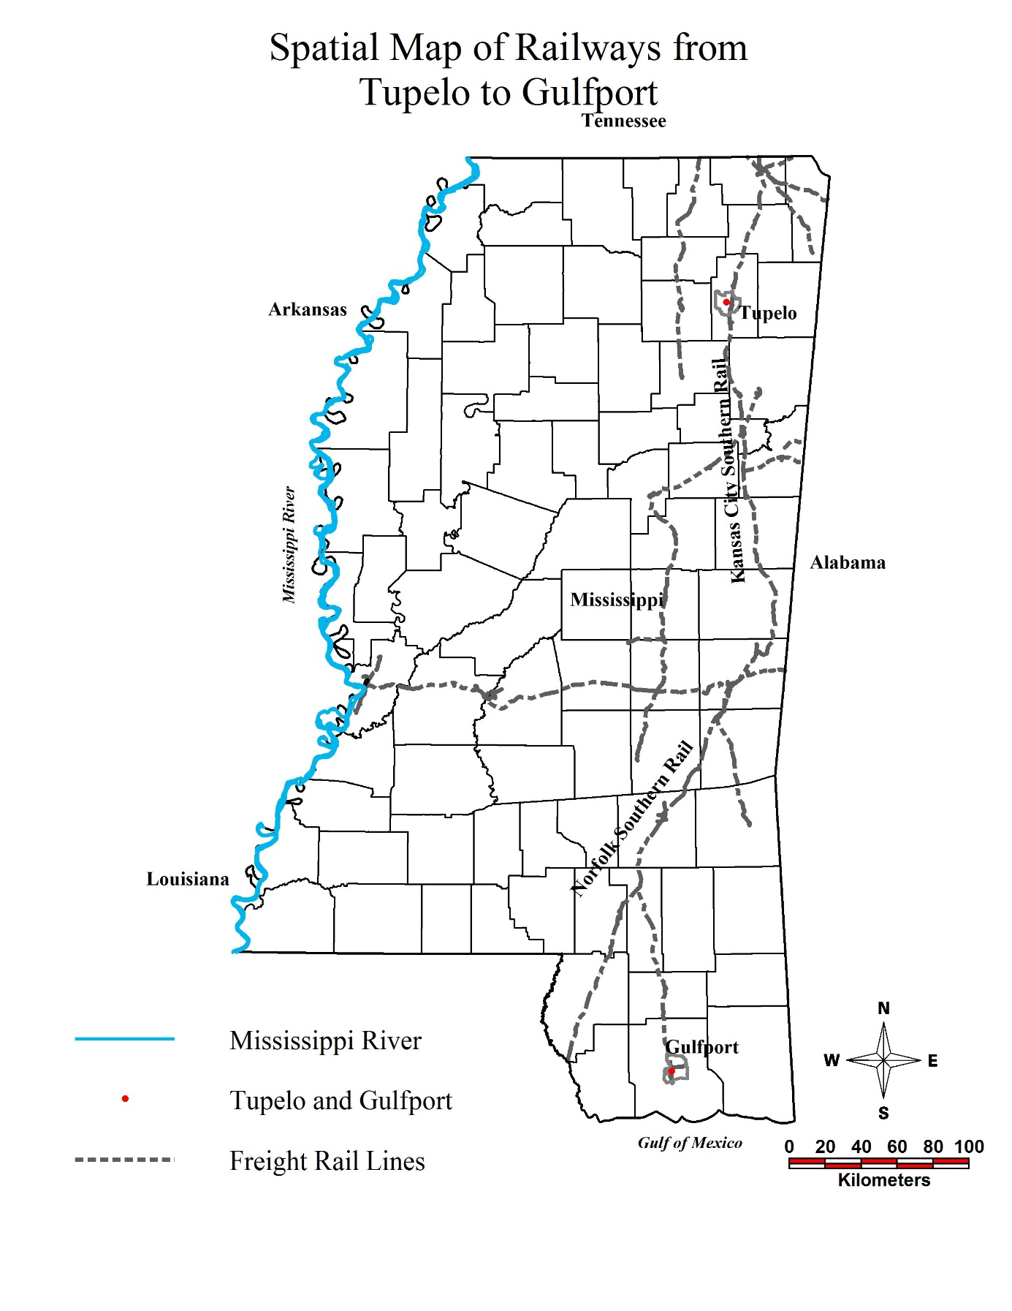

**Spatial Map of Railways from Tupelo to Gulfport, Made November 29, 2017, using MS.mdb database information**

**Appendix II**

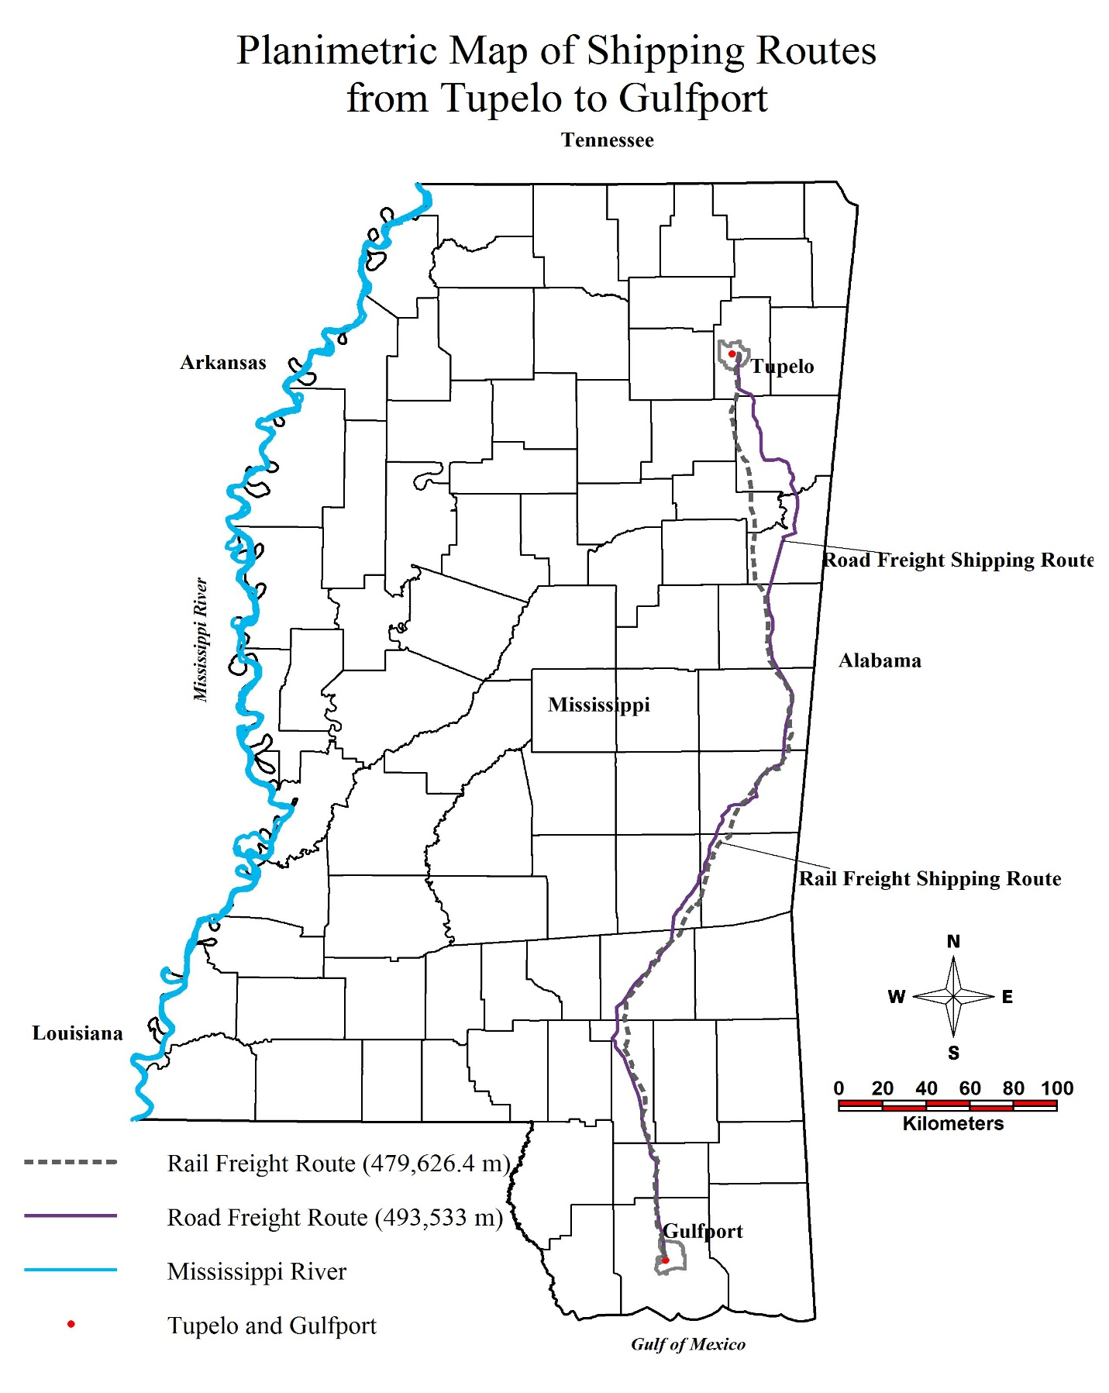

**Planimetric Mapping of Commodity Shipping Routes from Tupelo, MS, to Gulfport, MS, Made November 29,2017**

**Appendix III**

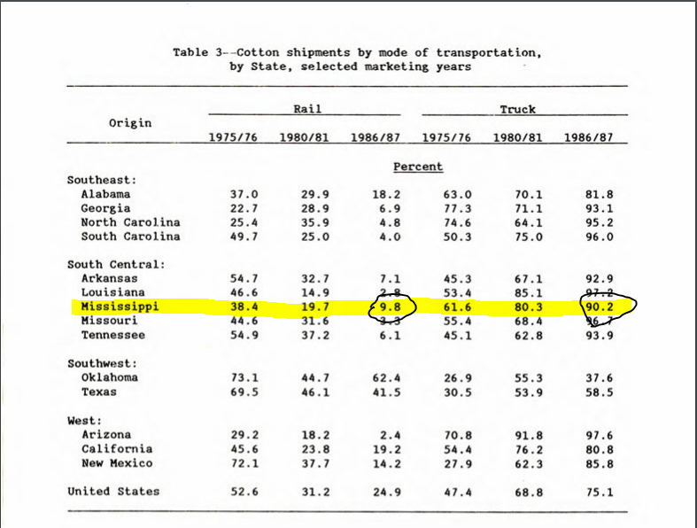 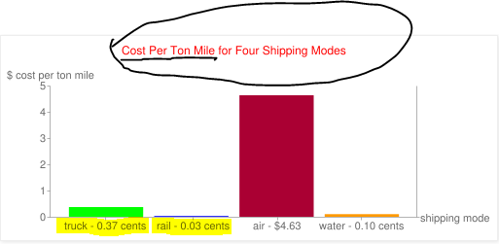

**Appendix III**

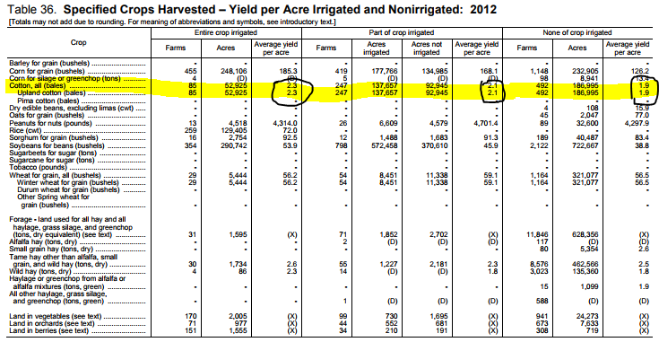

**Appendix IV**

*References:*

Uddin, Waheed, Dr. CE 581: Multimodal Transportation Engineering. Vol. Course Resource Notebook.Print, 2017.

Uddin, Waheed, Dr. CE 495: Geospatial Analysis and Visualization Applications. Vol. Course Lecture Notebook.Print, 2016.

Uddin, Waheed, Dr. CE 481: Transportation Engineering I. Vol. Course Lecture Notebook.Print, 2014.

US Department of Agriculture — [www.ams.usda.gov](http://www.ams.usda.gov), Accessed 19 November 2017

US Census — www.factfinder.census.gov, Accessed 19 November 2017

TX Tech University — [www.depts.ttu.edu](http://www.depts.ttu.edu), Accessed 25 November 2017

Torian, Richard — richardtorian.blogspot.com, Accessed 25 November 2017

Cotton — <http://www.cotton.org/econ/cropinfo/costsreturns/portal.cfm>, Accessed 23 November 2017

Cotton — <http://www.cotton.org/tech/bale/bale-description.cfm>, Accessed 23 November 2017

EPA — <https://www3.epa.gov/ttnchie1/conference/ei20/session8/mbergin.pdf>, Accessed 30 November 2017

TennTom — <http://business.tenntom.org/why-use-the-waterway/shipping-comparisons/>, Accessed 30 November 2017